**Oracle 19C on Windows - VM**

**Overview:**

I focus on installing Oracle 19c on a Windows Server 2012R2 environment. Now, for our Lab practical we have to configure VM to fulfil Oracle 19c minimum requirements. Hence, Our PC performed smoother without hampering our daily work with PC.

**VM Configurations for Oracle 19C:**

I will be prepared step by step for configure VM to install Oracle 19C.

Software required:

1. For VM – Vmware-workstation-full-15.5.6-16341506
2. For Windows – Windows Server 2012-64x.ISO
3. For VM Free License Key - <https://gist.github.com/gopalindians/94c2c8617028cfe7a5788f760e036fd2>

FU512-2DG1H-M85QZ-U7Z5T-PY8ZD

CU3MA-2LG1N-48EGQ-9GNGZ-QG0UD

GV7N2-DQZ00-4897Y-27ZNX-NV0TD

YZ718-4REEQ-08DHQ-JNYQC-ZQRD0

GZ3N0-6CX0L-H80UP-FPM59-NKAD4

YY31H-6EYEJ-480VZ-VXXZC-QF2E0

ZG51K-25FE1-H81ZP-95XGT-WV2C0

VG30H-2AX11-H88FQ-CQXGZ-M6AY4

CU7J2-4KG8J-489TY-X6XGX-MAUX2

FY780-64E90-0845Z-1DWQ9-XPRC0

UF312-07W82-H89XZ-7FPGE-XUH80

AA3DH-0PYD1-0803P-X4Z7V-PGHR4

**Followed Steps:**

Step 1: From you PC chose the free space

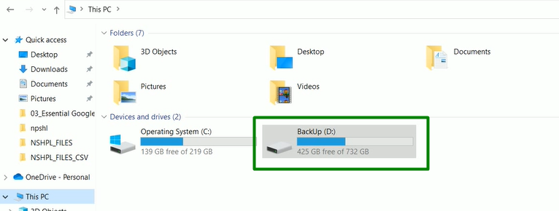

Step 2: Create a Directory for separate VM Storage (e.g. D:\VM_Space\Office\Oracle19C)

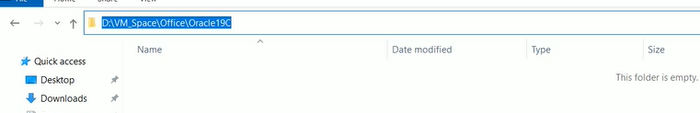

Step 3: Launch the VM to Create New VM Machine

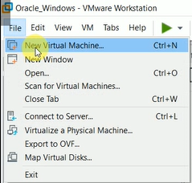

Step 4: Now follow the VM Wizard by choosing the Typical option and then click “Next”

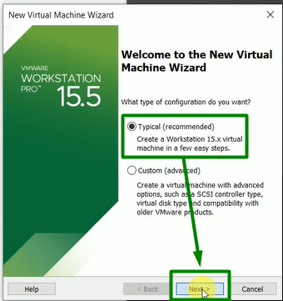

Step 5: Choose the disc image option and the click “Next”

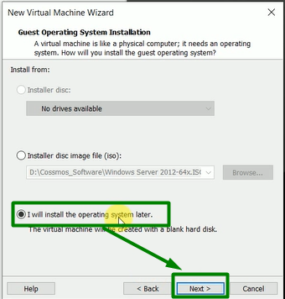

Step 6: Choose the Operating System and version options and then click “Next”

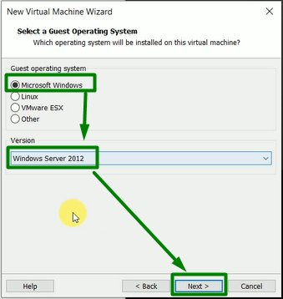

Step 7: Choose the VM Location from Created Directory – “Step 2”, Named the New VM Machine and then click “Next”

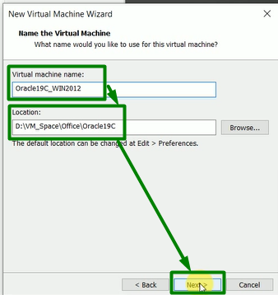

Step 8: Define the disk size, Select as Store Disk type and then click “Next”

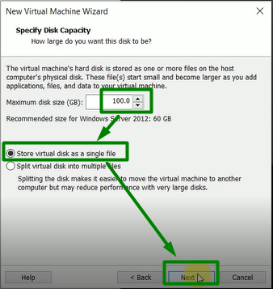

Step 9: To Customize the VM hardware click “Customize Hardware”

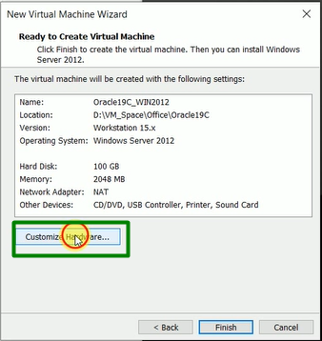

Step 10: After clicking on “Customize Hardware” there is another window appeared and the you have modify and remove the highlighted area

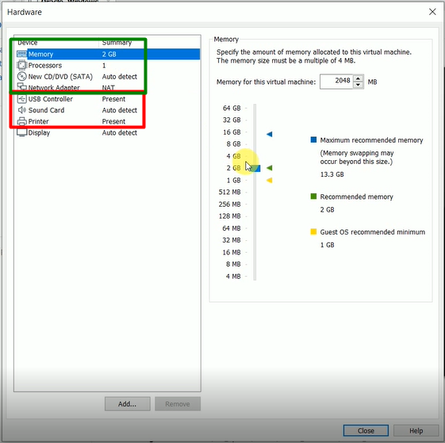

Step 11: You have modify VM hardware Memory, Processors, New CD/DVD and Network Adapter by Click on relevant terminology

Memory:

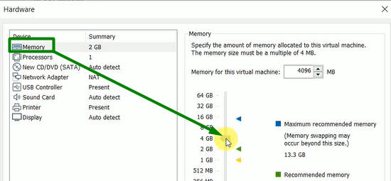

Processors

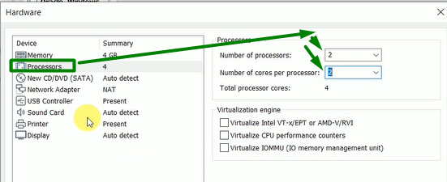

New CD/DVD (Select the “Windows Server 2012-64x.ISO” image file )

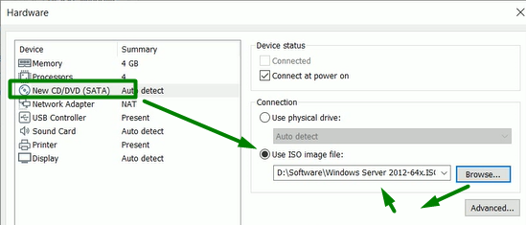

Network Adapter

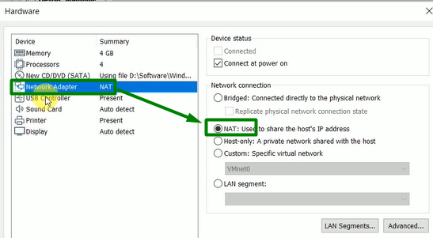

Step 12: You have to remove the un-necessary resources for this project

USB Controller

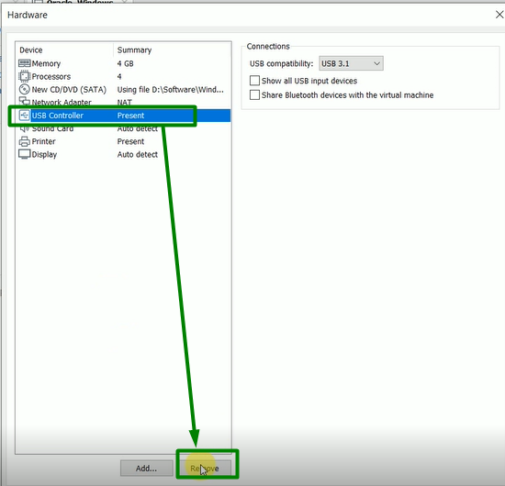

Sound Card

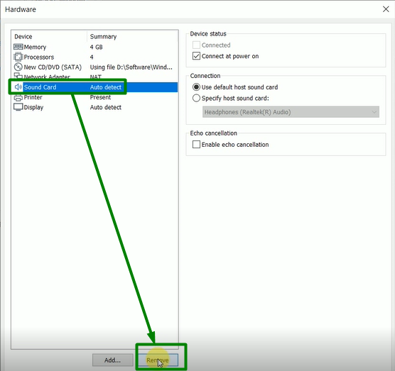

Printer

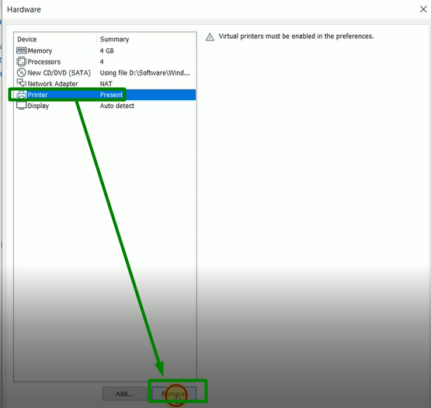

Step 13: After successful Alter and Removable process click on “Close”

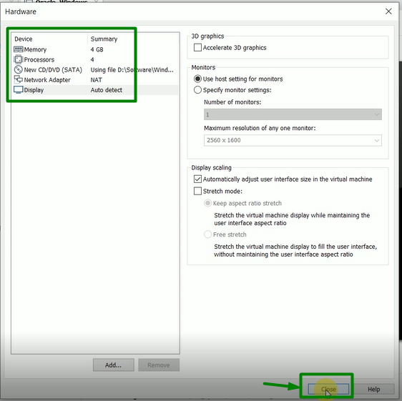

Step 14: After successful configuration of VM hardware process click on “Finish”

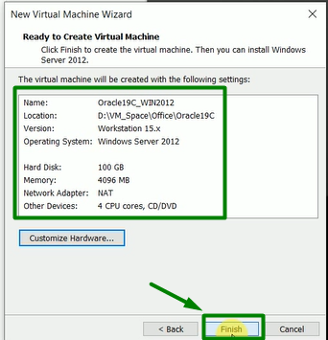

Step 15: Let’s Open the New VM “Oracle19C_WIN2012” to install the Windows Server 2012R2 by click on “Power on this virtual machine”

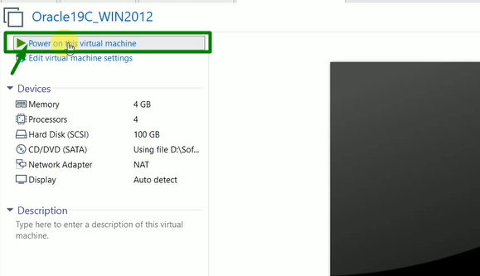

Step 16: Let’s setup the “Windows Server 2012R2” on the New VM “Oracle19C_WIN2012” by selecting proper steps and click on “Next”

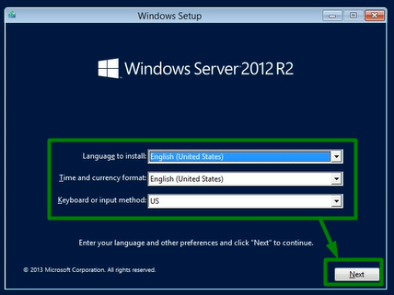

Step 17: Click on “Install now”

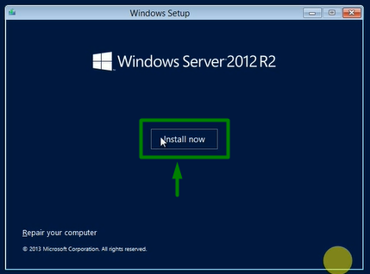

Step 18: Choose the “Windows Server 2012 R2 Standard (Server with a GUI)” and click on “Next”

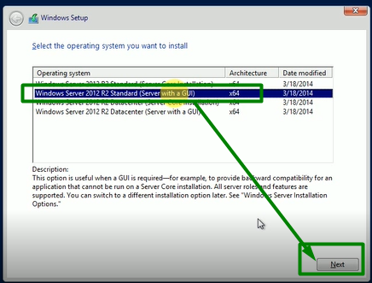

Step 19: Accept the license terms and click on “Next”

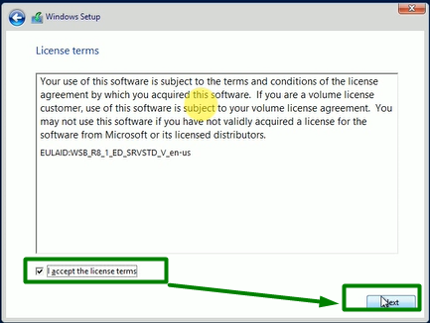

Step 20: Continue with the “Custom” Option

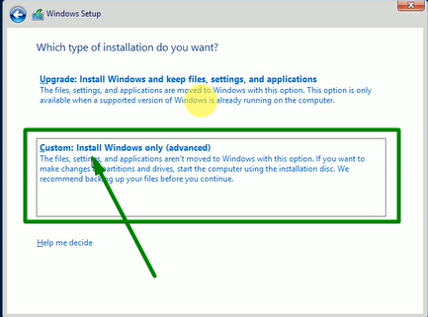

Step 21: Continue by selecting storage and then click on “Next”

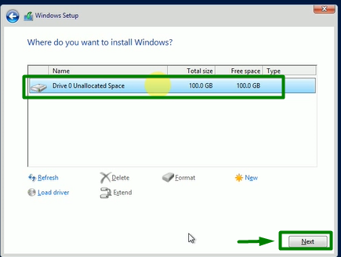

Step 22: Waite for finch the setup

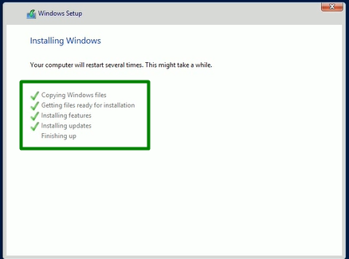

Step 23: Auto Restarting the VM

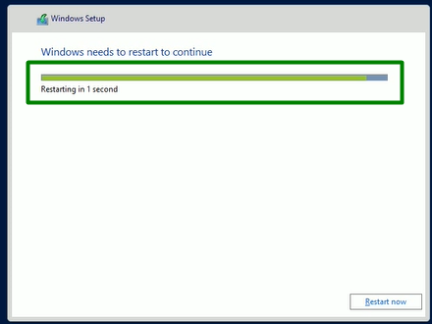

Step 24: Provide the New VM Admin password

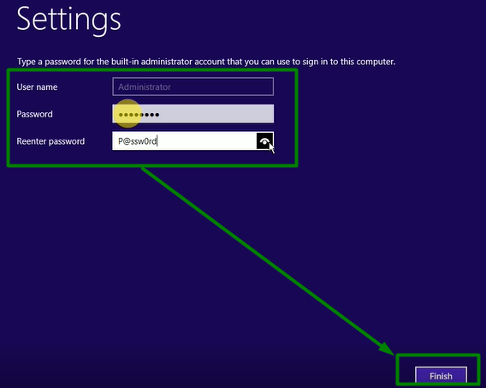



Step 25: After restart Looking for “Press Ctrl+Alt+Delete to sign in.” then Click on multiple square sign on menu tab of your VM then provide the Admin password to login.



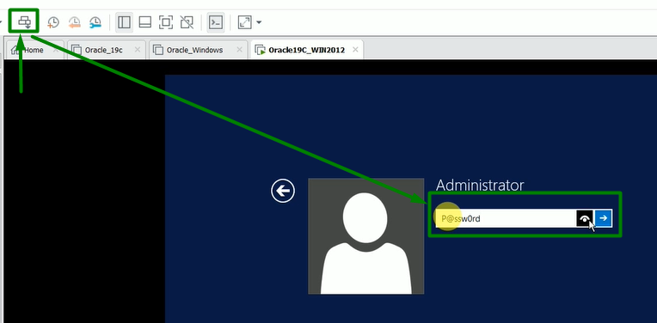

Step 26: For network setup Click on “Yes”.

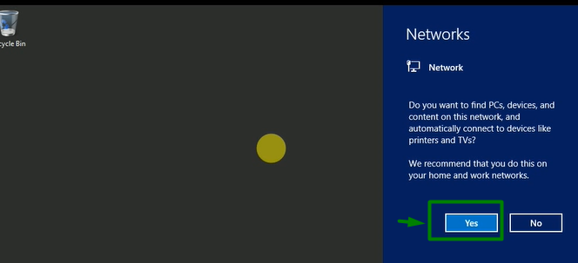

Step 27: Finally configure the VM tools, Select New VM “Oracle19C_WIN2012” then right click and then Click “Install VM Tools”

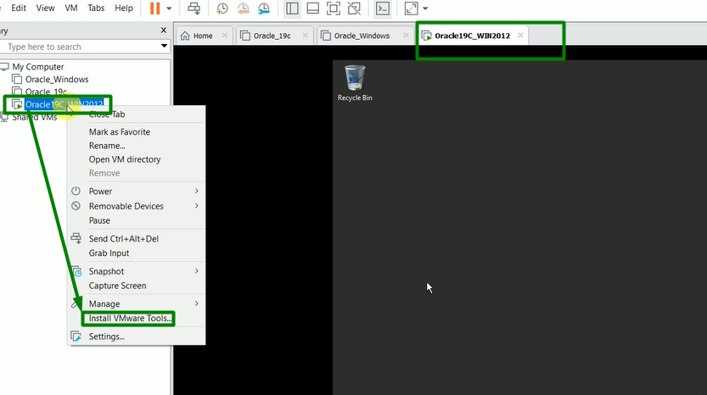

Step 28: Click on “DVD Drive (D) VMware Tools”

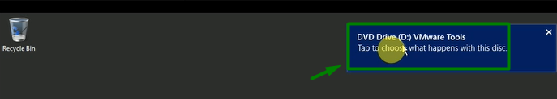

Step 29: Click on “Run setup64.exe”

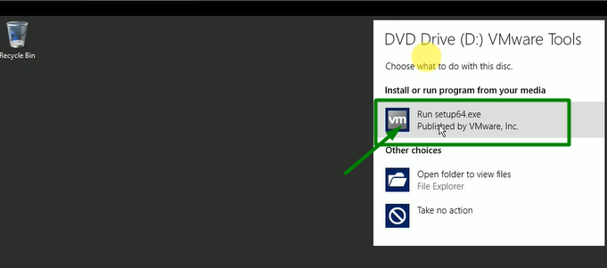

Preparing setup (It will take some time to appear)

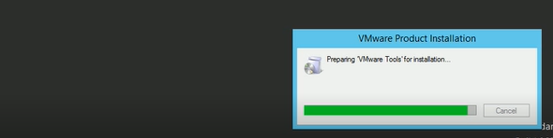

Step 30: Follow the VMware tools step wizard `by Click “Next”

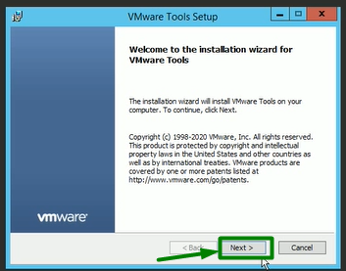

Step 31: Select the “Typical” option then Click “Next”

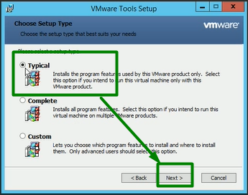

Step 32: Click on “Install”

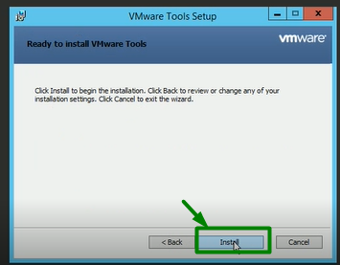

Step 33: Click on “Finish”

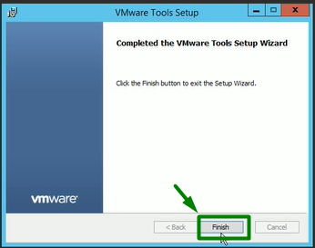

Step 34: Click on “Yes” to finalize the setups

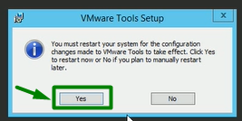

**Oracle 19C Installation Steps**

Perform the following steps to install Oracle 19c on Windows - Windows Server 2012R2:

Step 35: Follow the Links to Download the Oracle 19c for Windows

Download the software **WINDOWS.X64_193000_db_home.zip** from the following Link: <https://www.oracle.com/database/technologies/oracle-database-software-downloads.html>

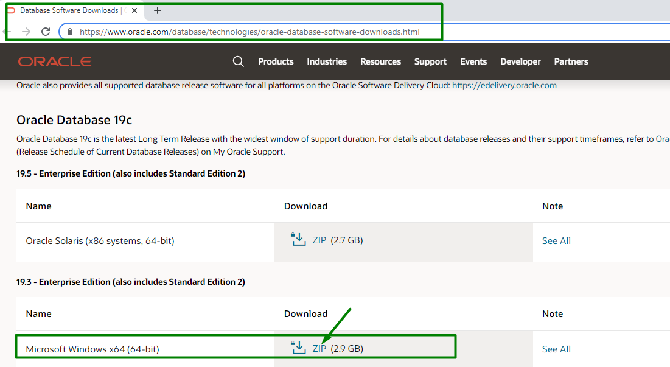

**Or**

Link: <https://www.oracle.com/in/database/technologies/oracle19c-windows-downloads.html>

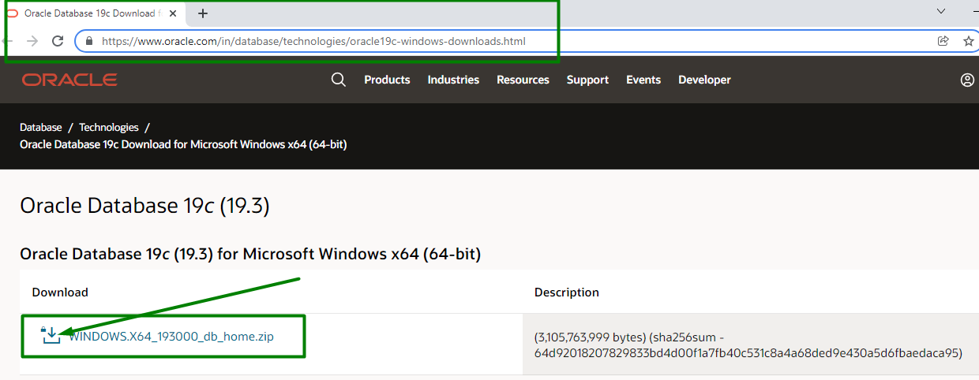

Step 36: Copy and Create directories in your New VM for Software and Oracle home location

1. Copy the zip file “**WINDOWS.X64_193000_db_home.zip“** intonewly created folder **“C:\app\product\”**

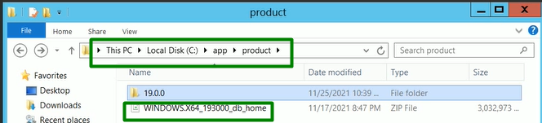

1. The extract into new created folder to **C:\app\product\19.0.0\dbhome_1**, which is the Oracle 19C Home directory.

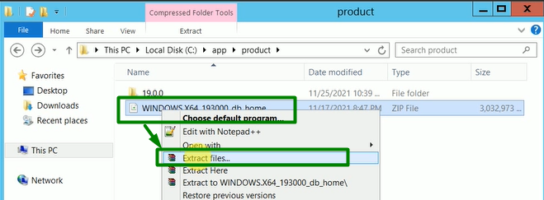

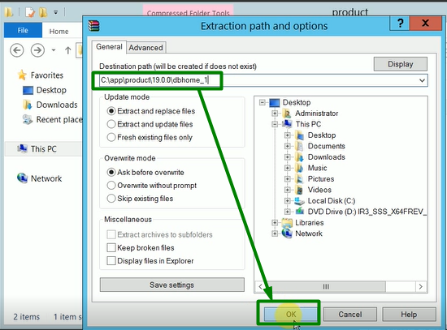

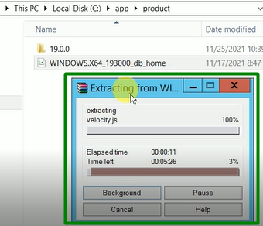

Step 37: After the zip extraction completes, execute **C:\app\product\19.0.0\dbhome_1\setup.exe** and perform the following installation steps.

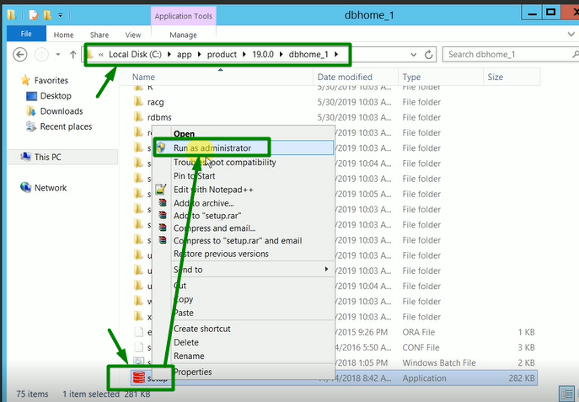

Step 38: After the zip extraction completes, execute **C:\app\product\19.0.0\dbhome_1\setup.exe** and perform the following installation steps.

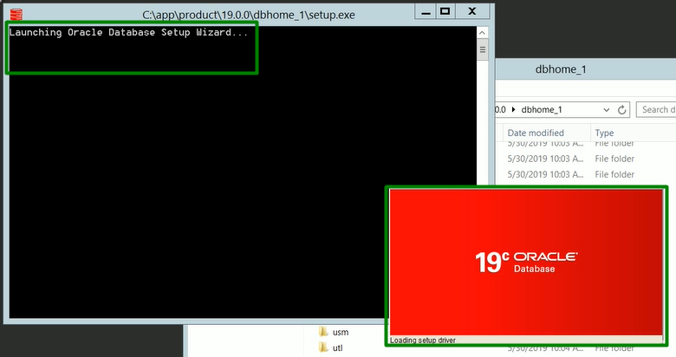

Step 39: Select “Create and configure..” option and then click on “Next”.

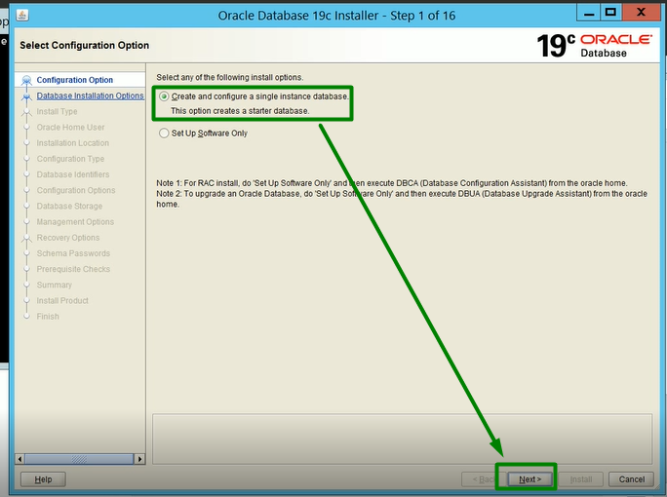

Step 40: Select “Desktop class” option and then click on “Next”.

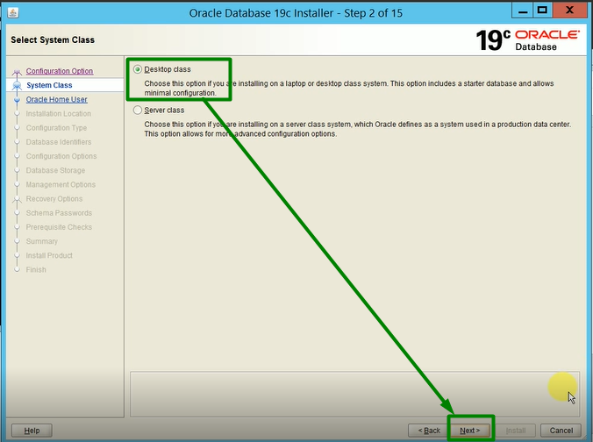

Step 41: Select “Use Virtual Account” option and then click on “Next”.

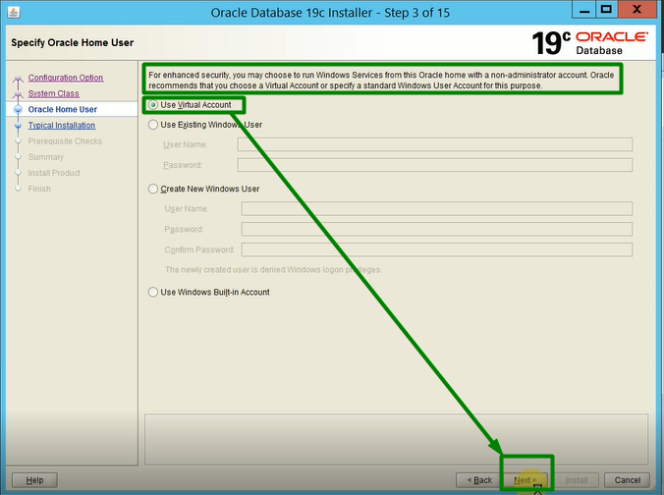

Step 42: Go with directories and change the SID, put the password and then click on “Next”.

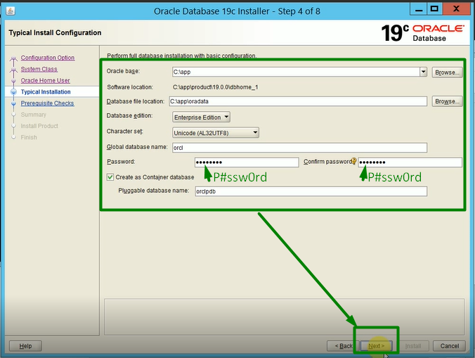

Step 43: Wait util 100% completion of Oracle verification process for your VM Configuration

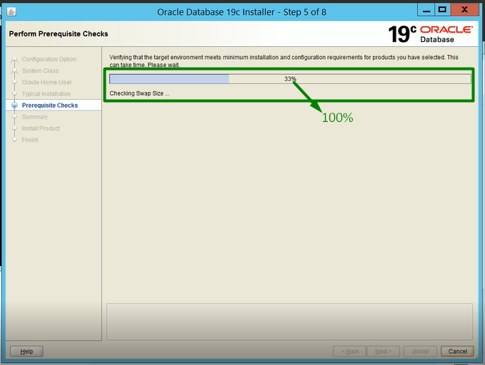

Step 44: After Oracle Verification process completes, then start installation process by Click on “Install”

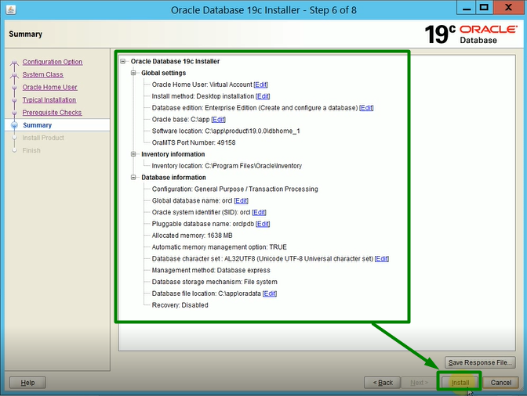

Step 45: Wait for installation process util 100%

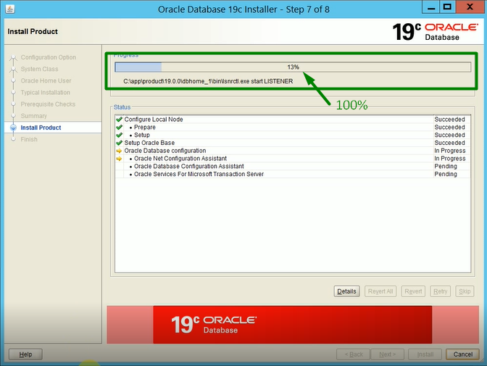

Step 46: Now close Oracle wizard after successful by click on “Close”.

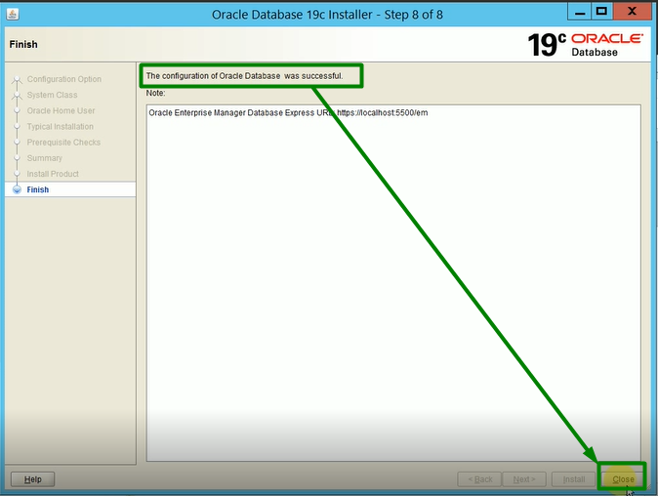

Step 47: Open your power shell as Administrator.

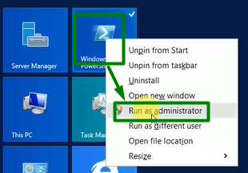

Step 48: Set your SID **orcl** and then issue the command to enter in Oracle 19C.

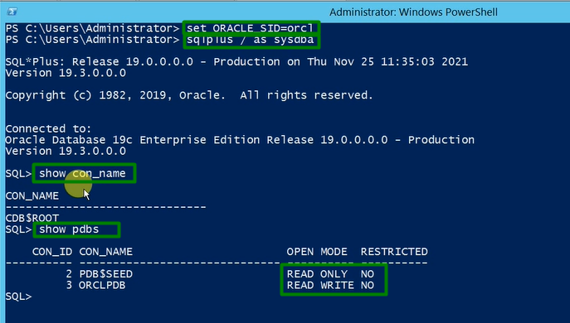

Step 49: Set your pdb’s all up and make it save for every time.

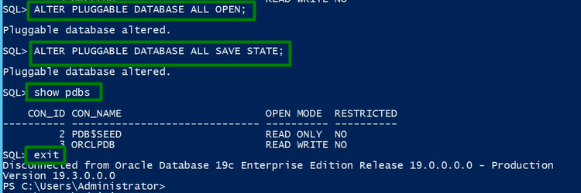

Step 50: Create New folder for JDK configuration or Find it

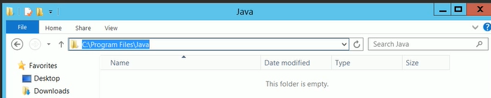

Step 51: Download and Extract the file “**jdk1.8.0_77.zip**” at Java location “**C:\Program Files\Java**”.

Link: <https://downloads.ensemblevideo.com/Temp/Java/>

1. Download:

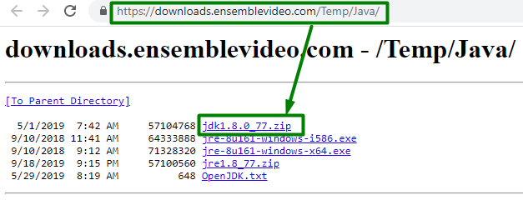

1. Extract:

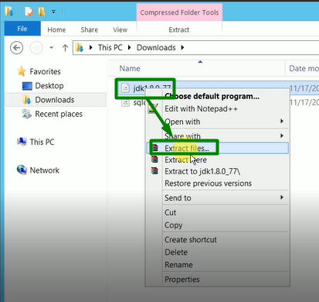

1. Locate:

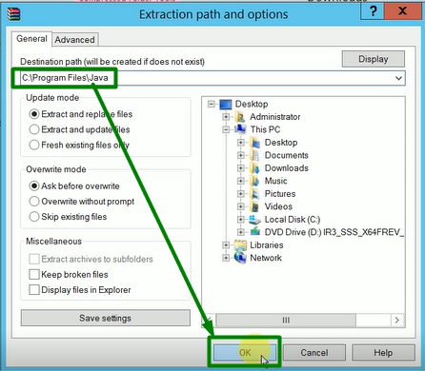

1. Progress:

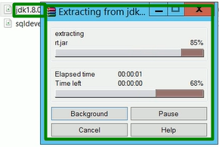

Step 52: Find the java version from it installed location “**C:\Program Files\Java\jdk1.8.8_77\bin**”.

1. Location:

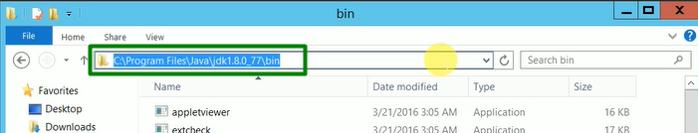

1. Type “**cmd**”

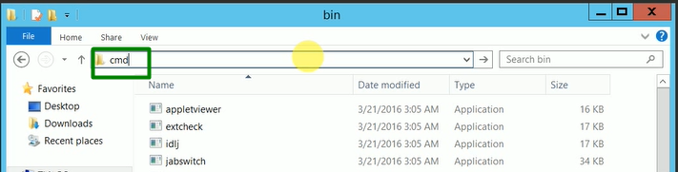

1. Find java version by typing “**java -version**”

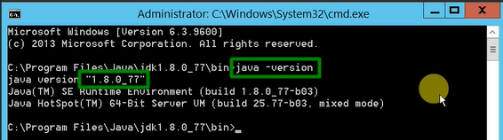

Step 53: Set the environment variables (**JAVA_HOME, ORALCE_HOME & ORACLE_SID**).

1. Go to My Computer then right click and then click on “Properties”

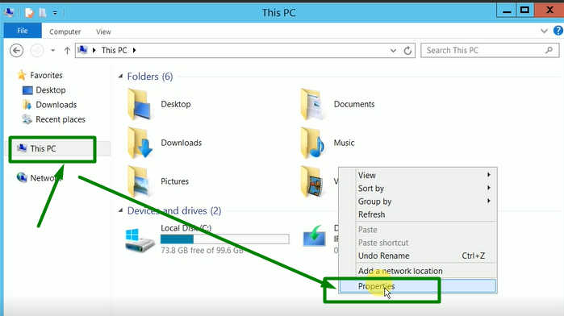

1. Click on “Change setting”

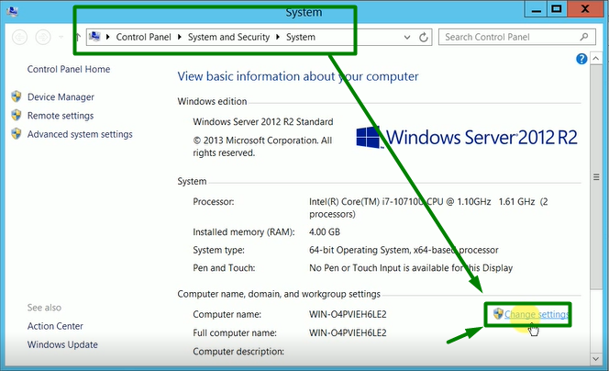

1. Click on “Advanced” and then click on “Environment Variables”

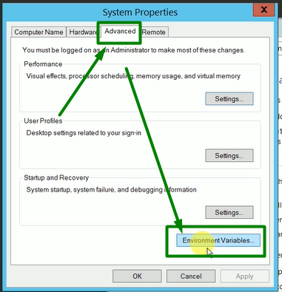

1. Select the “PATH” and then click on “Edit…”

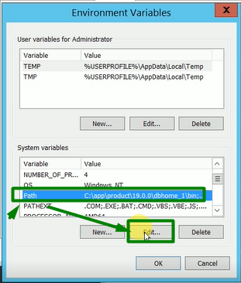

1. In the last of “Variable value” Put the semi colon “;” and path of java bin “**C:\Program Files\Java\jdk1.8.8_77\bin**” and then click on “OK”

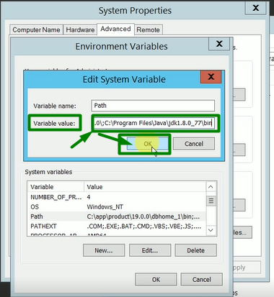

1. Click on “New…” then Define the “Variable name:” then “Variable value” as “**C:\Program Files\Java\jdk1.8.8_77**” and then click on “OK”

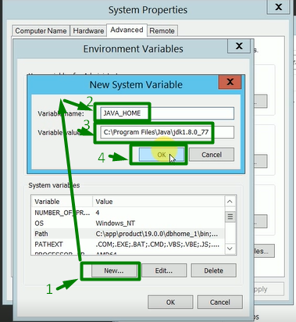

1. Click on “New…” then Define the “Variable name:” then “Variable value” as “**C:\app\product\19.0.0\db_home_1**” and then click on “OK”

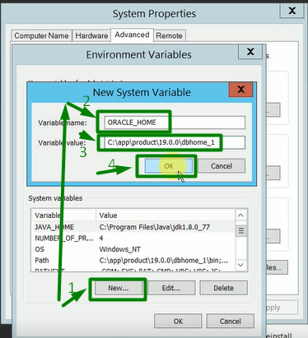

1. Select the “PATH” and then click on “Edit…”



1. In the last of “Variable value” Put the semi colon “;” and path of Oracle “**C:\app\product\19.0.0\db_home_1**” and then click on “OK”

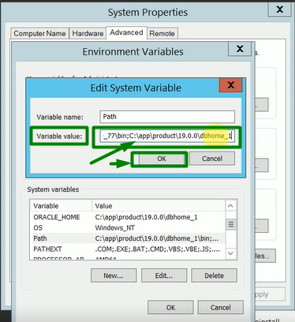

1. Click on “New…” then Define the “Variable name:” then “Variable value” as “**orcl**” and then click on “OK”

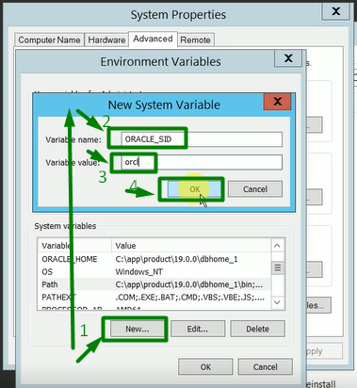

1. Click on “OK” to save and exit

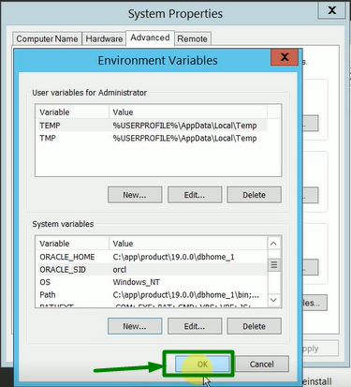

1. Click on “OK” to save and exit

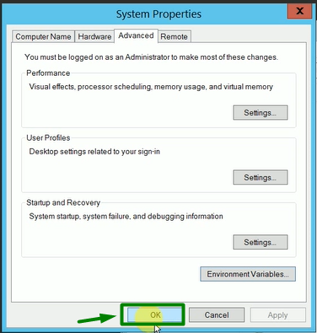

1. Close the “System” to finish environment variable setting

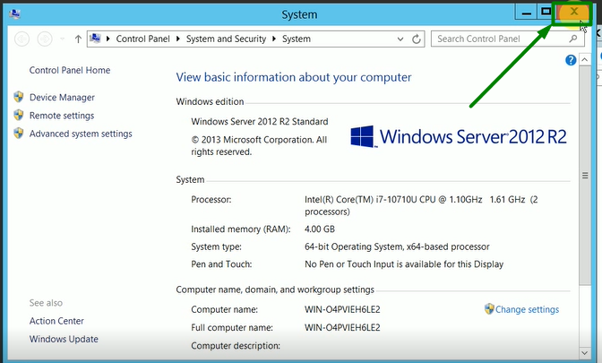

Step 54: Create New folder for SQL Developer 21.2.1

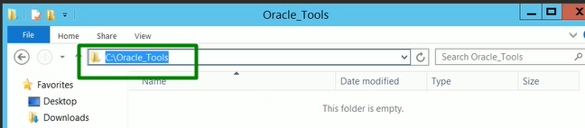

Step 55: Download and Extract the file “**sqldeveloper-21.2.1.204.1703-no-jre.zip**” at location “**C:\Oracle_Tools**”.

Link: <https://www.oracle.com/tools/downloads/sqldev-downloads.html>

1. Download:

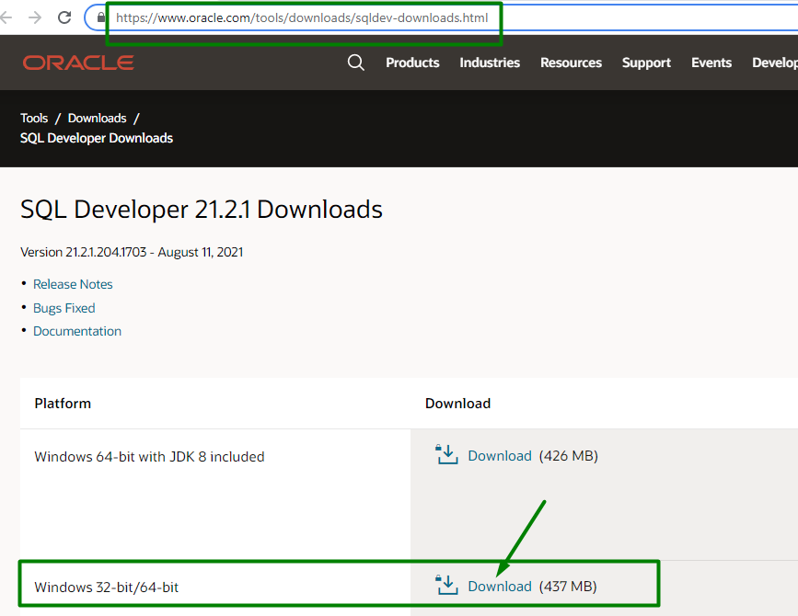

1. Extract:

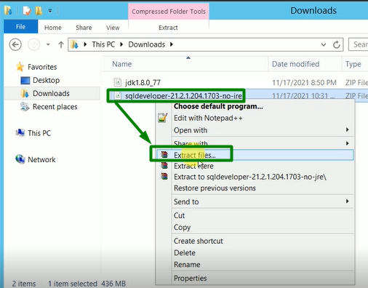

1. Location:

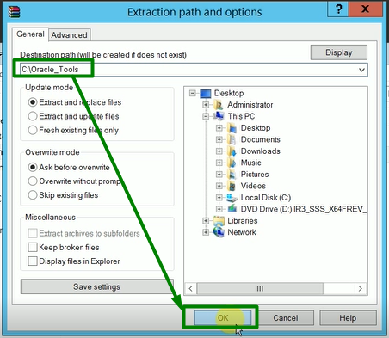

1. Progress:

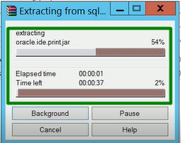

Step 56: Configure the SQL Developer 21.2.1

1. Locate the exe file “**C:\Oracle_Tools\sqldeveloper\**”

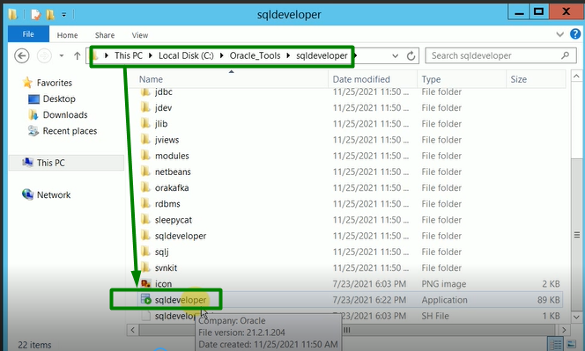

1. Pin to taskbar “**C:\Oracle_Tools\sqldeveloper\sqldeveloper.exe**”

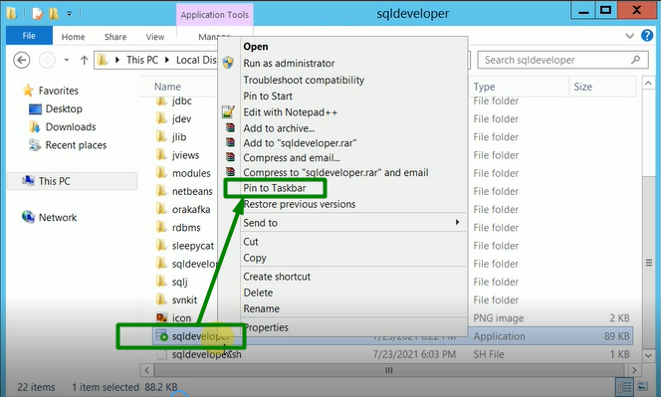

1. Click on i-cone of “sqldeveloper.exe” and the follow the steps for JDK

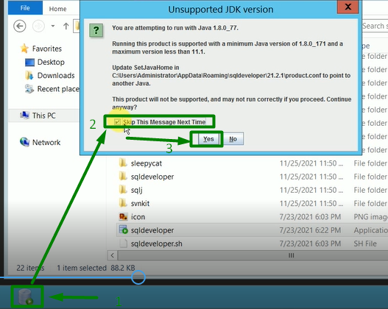

1. Click on “OK”

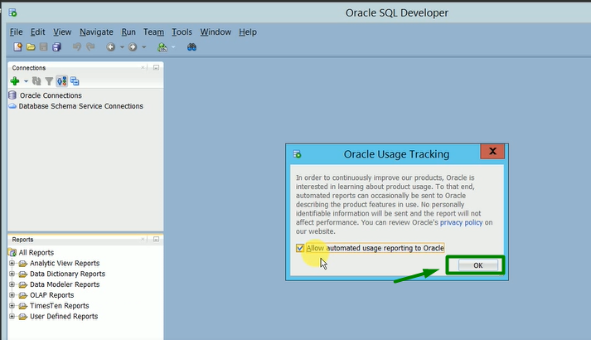

Step 57: Configure the Oracle TNS and Listener for external tools “**C:\app\product\19.0.0\db_home_1\network\admin\”**

1. Edit the “**tnsnames.ora**”

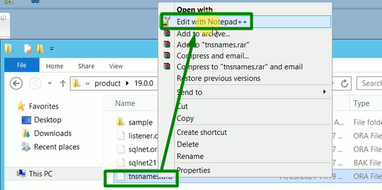

1. Add configuration for SID “**orclpdb**” in the “**tnsnames.ora**”

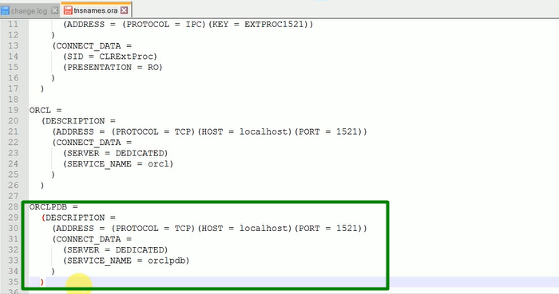

1. Edit the “**listener.ora**”

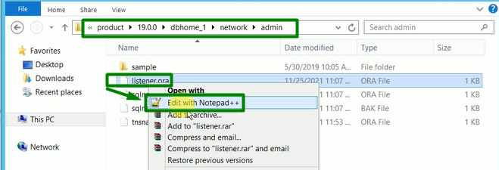

1. Configure the “**listener.ora**” for SID “**orcl**”

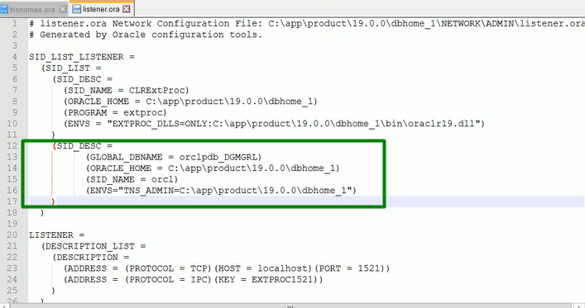

1. Open the “Power Shell” and check the status of “**Listener**”

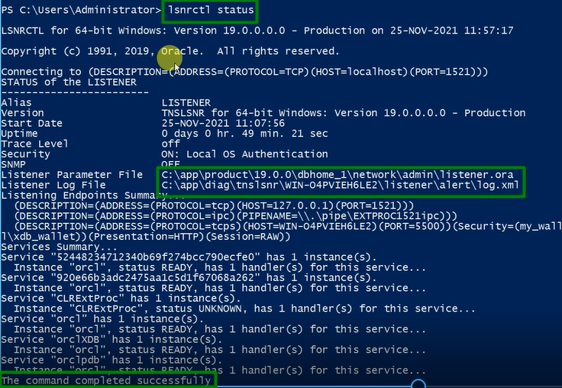

1. Stop the “**Listener**”

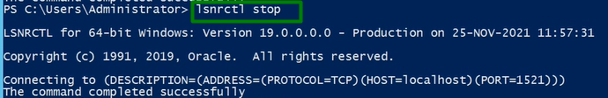

1. Start the “**Listener**”

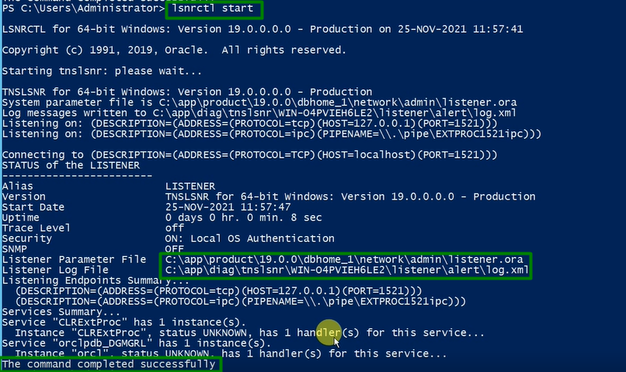

1. Check the “**TNS**”
2. SID **orcl**

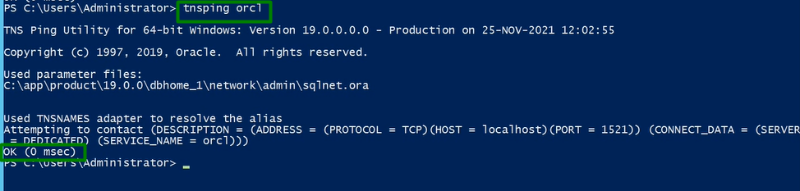

1. SID **orclpdb**

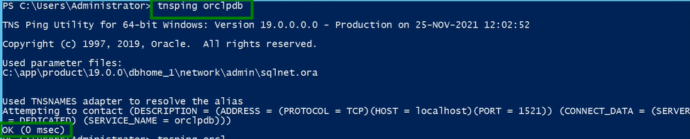

Step 58: Verify the DB and Unlock the User HR

1. Sys user of root seed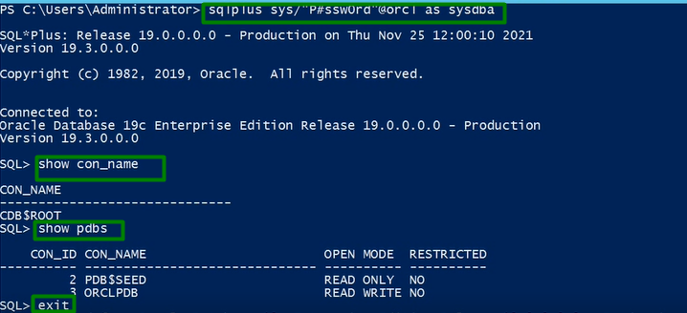
2. Sys user of pdb’s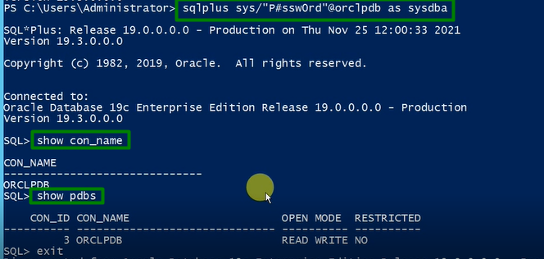
3. Unlock the user HR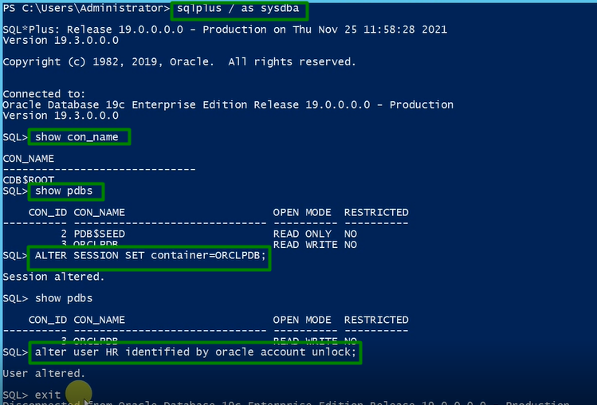
4. Verify the user HR connection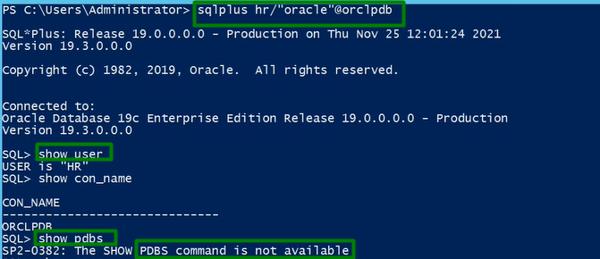

Step 59: Connect the User’s using **SqlDeveloper**

1. Sys user of root seed

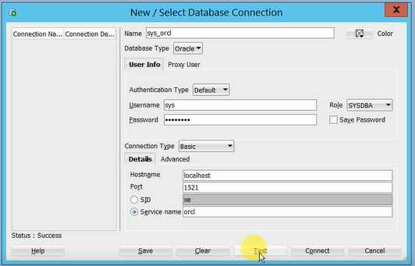

1. Sys user of pdb’s

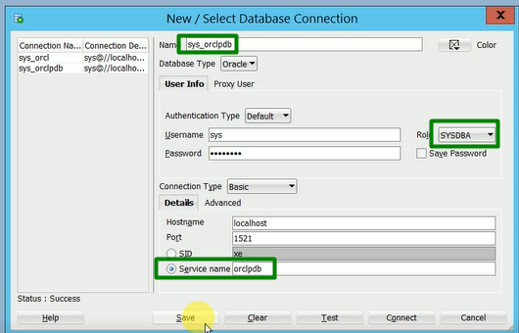

1. HR user of pdb’s

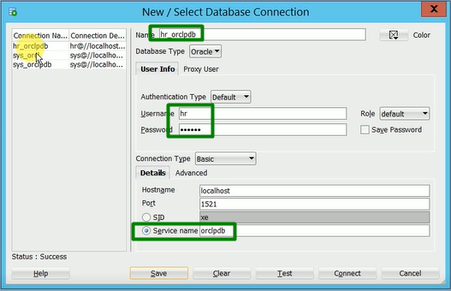

Step 60: Import SCOTT user using **impdp**

1. Create user and Grant user “Scott” from Sys user of pdb’s

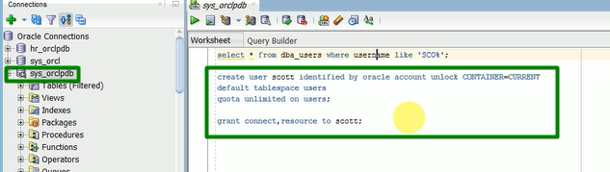

1. Place the dump file on newly created folder “**C:\app\DUMP_DIR**”

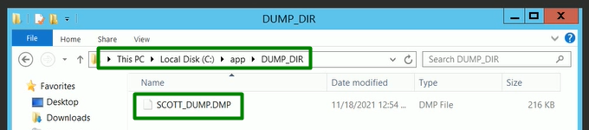

1. Create a directories from Sys user of root seed for newly created folder “**C:\app\DUMP_DIR**”

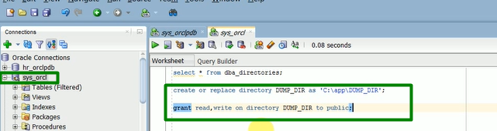

1. Import dump using SCOTT user in pdb’s

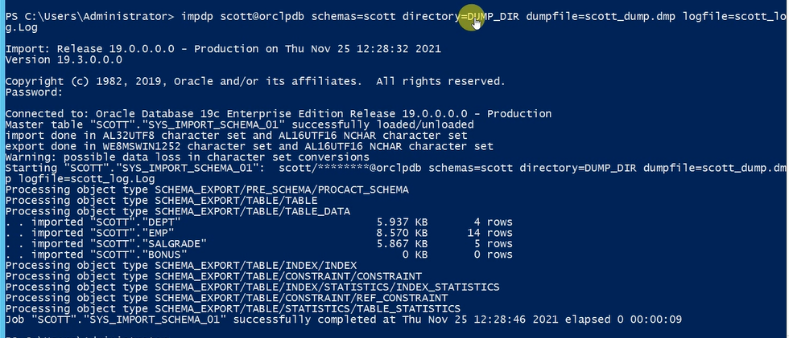

1. Connect SCOTT user using **SqlDeveloper**

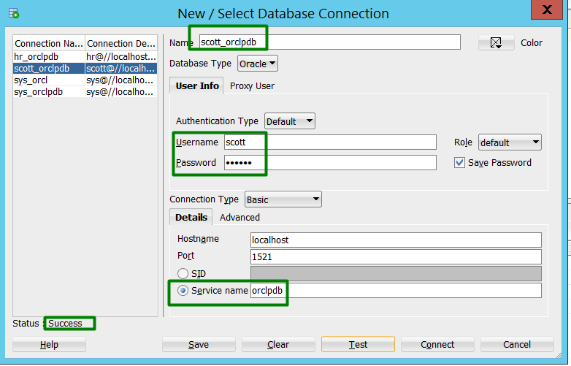Prepared By: Er. Devesh Kumar Shrivastav designated as Senior Principle Oracle Database Administrator / Performance Tuner.

Thank You.